Service Structure Committee Minutes
January 29, 2018 * 8 PM EST
712-770-4010 ACCESS CODE: 281687#

Serenity Prayer:
God, grant me the serenity
To accept the people I cannot change, the courage to change the one I can, and the wisdom to know that one is me.

Members Present: Marcia, Mary Jo, Carole, Matt K, Sarah O.

- Purpose: As a committee of the ACA WSO, our purpose is to research the service structures of other global fellowships in order to recommend how ACA should best organize its service structure to serve its growing fellowship nationally and globally.

Goals:
  - Research and define regions for a recommendation to the ABC and ACA/WSO Board
  - Come up with a 5-year vision for the implementation of a Regional structure.
  - Create a plan to start the process.

- Responsibilities:
AA--Miles | DA--Bonnie | NA--Matt
ACA--Carole C. | CMA--Marcia | OA--Marcia
Al Anon--Mary Jo | CoDa--Sarah O. | SAA--Charlie

OLD BUSINESS
- Motion to approve the minutes from the January 15, 2018 meeting. (Marcia)
Second: Matt K.
Discussion:
Decision: Passes unanimously

- Vision and Mission Statements:

Vision Statement: Regional Service Committees build bridges of communication and support to bring Adult Children out of isolation and into fellowship.

Mission Statement: Whenever an adult child reaches out, the Regional Service Committees will be there with information and support: to connect people within the fellowship, to encourage participation as trusted servants, and to grow meetings full of experience, strength and hope throughout the world

- Some members expressed concern that the Mission Statement indicates a role for Regions that is more like the actual role of Intergroups.
- The insight had been brought up in a previous meeting, but at that time it was thought that perhaps all the structures would have a similar mission that built on the one below or above it.
- The current status leaves Regions as the only link between some meetings and the WSO. This insinuates a more hands-on role.
- The real role of the Regions may be to encourage the formation of Intergroups who would be in a better position for hands-on involvement, as well as promoting Service Work.
- The Region could be more than a trainer than foot soldiers. There might be a limited role of Regions filling more immediate needs.
- The Mission Statement was created during two meetings and voted upon at that time. There is a reluctance to revisit it.
- Those currently working to set up a Region are not now bound by any statements, since they have not been approved by the WSO or the ABC.
- At the same time, if we see flaws or changes during our work on Regions, we should not hold ourselves to a previous decision, but allow ourselves to return and make amendments.
- Because of the low turnout for tonight’s meeting, Marcia does not want to make changes to wording that was important to some who are not present. However, we will revisit the statement.
- What is the role of Regions as it relates to Intergroups? Do we need other structures between Regions and Intergroups? Are we looking to revisit the Regional Role in 5 years?

- Brainstorming Grid (See above statements)

Communication | Connect People | Encourage Participation
- Resource repositories  - Website  - Newsletter  - WSO Regional Sponsor  - Call meetings within regions to check in and chat | - Regional Forums (Teleconferences)  - Contact IGs/Meetings  - Create/maintain/update/ distribute lists:  - Meeting list booklets  - Trained servant contacts  - Speaker/workshop contacts  - Social events  - Potlucks  - Ice cream socials  - Holiday parties/dances  - Visits to local attractions  - Walk and Talk  - Gratitude meetings  - Speaker meetings | - Training of trusted servants.  - Education  - Human resources  - Service Mentoring  - Train the Trainer  - Create literature to encourage and guide ACA newcomers and members in service at the group, intergroup, and regional areas.  - Invite a group member to help with some service event you are participating in.
Grow Meetings | Encourage Recovery | Legal/Representational
- Proactive Support for meetings and Intergroups.  - Public Information  - Community Outreach in underserved areas.  - Donate books to libraries  - Fellowship events  - Sponsor someone as they start a new meeting. | - Best Practices Page  - Workshops  - Speakers  - Sponsorship workshops  - 4th Step writing meetings  - Reparenting support group  - Reparenting workshop  - Anniversary celebrations | - Regional “place holders”  - Board Regional Representative  - Bylaws  - Bank Account  - Officers  - Report back to groups/intergroups about WSO information and activities  - Report concerns to WSO  - Report regional ideas to WSO

- What does an organizational group need to accomplish before applying as a region?

- Notify the MPS Regional sub-committee and receive a mentor.

- Must represent a stated ACA demographic.
  - List of organized intergroups that will be included.
  - List of unaffiliated meetings that will be included.
  - List of organized intergroups and meetings that have expressed interest in being part of the region.
  - List of contacts that did not respond.

- Demonstrated Contact with the above demographic

- Must fill out paperwork:
  - Regional Officer Bios
  - Mailing information
  - Regional plan that speaks to the ACA Vision and Mission Statements for Regions
  - One-year plan and 5-year goals
  - Financial plan and budget

- Bylaws/Operating Rules

- Bank Account

- Creating a Regional Map
A spirited discussion was held using the map proposed by Bonnie K-M. Participants had strong feelings about it. There were issues of geography and population as well as cultural affinity that came up in the discussion. We have one established Region, and another is being formed. Respect for current boundaries, and the input of the international community were discussed. Inclusion of the Virtual Community will require some creativity. It was decided that each participant would create a map for the next meeting. They will be given time to present the map to the group. We can then look at strengths and weaknesses after the presentation.
The initial thought is to create a proposed map for comment and discussion by the fellowship before finalizing a map.

- Closing thoughts: Each person at the meeting was asked to take a minute to think about what they took away from it, and then given a chance to share the takeaway:

- We need to draw this map sooner rather than later, because it will be hard to change ownership once members start working to create Regions.

- We need to look at the current map. Member is feeling jazzed about more regions forming and crediting with gratitude the structure already in place. What states are in the regions we already have? What are the fellowship needs? Can we draw a map for structures currently in place or in the process of formation?

- Now thinking of Regions as having a role that focuses more on encouraging and supporting Intergroups and service leadership. Taking the size of population needs into consideration we need to make Regions smaller where there are higher populations and larger where there are smaller populations. There is a new awareness of looking at the world culturally and in language groupings.

- We need to begin on the map of the United States first. We need to talk to the international community before making arbitrary divisions.

- Feeling unsettled because work that seemed to be completed is now up for re-discussion. Once we look at maps, it brings to question what the purpose of Regions should really be, and whether or not we need to have a more complete discussion that involves the purpose of Intergroups and the creation of other structures that may be needed between the Intergroups and the Regions. Will there be time to complete this before the ABC? We may need to have weekly meetings or come up with additions to our Interim plan.

Next Meeting: Monday, February 12, 2018—8 PM EST

Appendix 1: Bonnie’s Suggestions—Regions outside the Box
From outside the box…
- Regions can serve as an administrative division of the fellowship along geographic lines. As such it would serve as a conduit for two way communication between local groups and WSO. Many issues could be addressed at the regional level, reducing the need for meetings to lobby WSO directly.

- Unlike local Intergroups, Regions would have fixed boundaries, serving all groups within them.
Regional designation would be automatic and based on a group’s location. Meetings would NOT need to take any action to formally affiliate; neither would they opt-out.

- Actual formation of an internal structure, the in-between, for a new region may develop organically, at the grass-roots level, as Region 2 has done. Meanwhile, there is nothing stopping several autonomous IGs from forming some sort of relationship/partnership to share/combine/enhance resources, including service volunteer efforts. I guess they could call themselves whatever they want, consortium, cooperative, living room. They are would not be WSO determined.
- Where a geographic Region has not formed an internal structure they could still have a Trustee appointed from and for that Region. Such a Trustee appointed for an unstructured Region could at least serve as a point of contact for communication between a Region’s meetings and WSO. Intercept some of the traffic, referring to various committees/trusted servants/special workers as appropriate. Additionally s/he may serve as WSO’s ambassador to existing ACA meetings, supporting and encouraging that Region’s internal development. A Trustee appointed to an unorganized Region might also function as a sort of “missionary”, targeting outreach. At the very least they would function as a sort of interim caretaker, a place-holder connecting a Region to WSO. Such appointed Regional Trustees would provide geographic balance to the Board.

- “Build it and they will come” seems most appropriate at this level. Establishing geographic Regions would provide a rudimentary administrative structure for WSO. We can provide a skeleton for the fellowship to flesh out as it grows. The ‘in-between structure would be focused on providing service and communication, not consolidated representation.

- As we grow we can maintain 1:1 voting strength for groups. Remote participation by large numbers of delegates is possible by consolidating what actually requires an up-down vote from the ABC. Developing structures to support this is a much more “shovel-ready” project than trying creating a structure of consolidated representation.

Appendix 2: A Regional Map Proposal
- Over time demographic changes will require any map to be revised. To provide continuity and stability the review should occur at fixed intervals, such as every 5 or 10 years.

- As a starting point: (Similar to the first one in Charlie’s document.)
- 4 regions in North America (roughly) by time zone, folding Alaska & Hawaii with the Pacific zone, adding all Atlantic & Newfoundland zones to the Eastern. This would promote better communication and cooperation across US northern & southern borders.
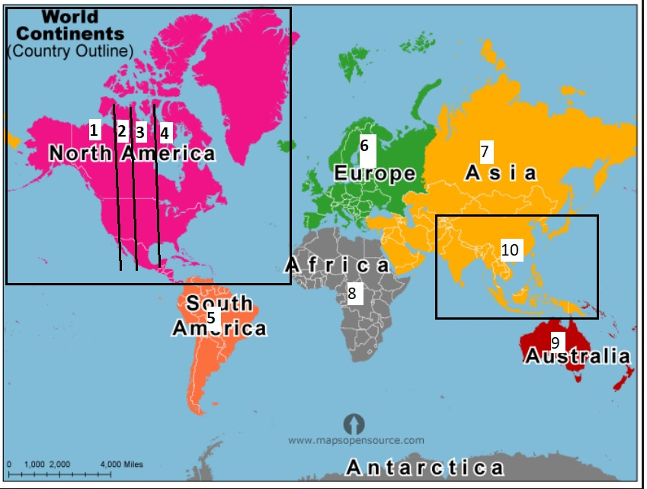
- The rest of the globe can be (flexibly) divided by continents:
- South America
- Africa
- Europe
- Asia
  - Australia, New Zealand, other islands and territories up to the International Date Line

- We should ask European, Russian and Asian groups to collaborate on their specific boundaries.

- Considering south-west Asia and the Indian subcontinent there could be 10.

- This isn’t too many trustees to add to the Board, especially if it is done in stages. The OPPM limits the number to 15, but the By-laws say 20.

- Some additional thoughts:

- Intergroups: (What we have now)
- Most meetings do not belong to an Intergroup.

- IGs are based on Voluntary affirmative affiliation.

- They are based on the needs, affinity, etc. of supporting groups.

- Intergroups are amorphous.

- The supporting groups determine the functions of the Intergroup: literature, meeting lists, H&I and PI functions, website, workshops, socials, whatever.

- IGs can (and do) form and disband at will. (Take your Teddy Bear and leave.)

- Regions: (The potential)

- As a geographic division it would be a fixed vehicle connecting WSO communication and service to all groups/meetings.

- All meetings would passively be fit into a specific region based on location.

- Groups who choose not to affiliate with any Intergroup would still be connected to their Region.

- As each Region is represented by a Trustee, the number of Regions must be fixed. Even without any developed internal structure, such as Intergroups, to nominate a candidate, an appointed Regional Trustee would become a point of contact between WSO and isolated, remote, or scattered meetings.

- Regions would not disband; they would remain constant once the ACA flag has been planted. (Apparently some Regional Trustees were appointed in 1990, so there is precedent for this.)

- There are advantages to fully autonomous self-driven service entities. There are advantages to fixed structure entities that can provide stability and continuity.
We can have the best of both!

