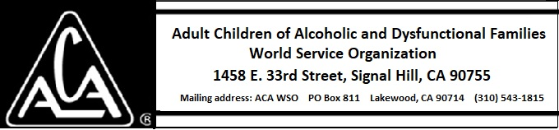

ARCHIVE COMMITTEE ACTIVITY DURING APRIL 2018

Presently, the Committee needs information about how to proceed. This could include surveying the archival systems of other 12 Step recovery organizations or similar non-profits. Our system of storage, digitization, and access will have to be explored. Standards and procedures surrounding acquisition of archival materials will need to be set.

The Committee is in need of a Chairperson. This leader, ideally, would have knowledge and experience with library science and curating archival material. Additionally, the Committee would like the involvement of members who have an interest in discovering and preserving the history of ACA. There will be tasks that can be accomplished both in California and at any distance.

Goals for 2018-2019

- Find a chairperson for the committee
- Identify committee members
- Establish a regular meeting time.
- Find out what has already been done.
- Investigate methods used by other organizations to curate materials.
- Establish an initial indexing system.
- Curate current materials using the indexing system with a documented index available to the Board of Trustees.
- Create or purchase necessary forms to track the work and meet legal needs.
- Establish a receiving and indexing system to deal with incoming materials.

Archival Material from Marty S. in California

Marty S., a former board member, has offered us archival material that he has at his home in California. Mary Jo L. plans to visit him and bring material back to Signal Hill.

