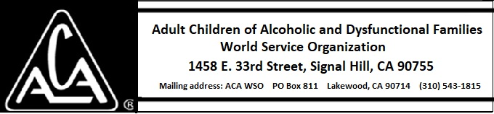

EXECUTIVE COMMITTEE ACTIVITY DURING APRIL 2018

There is no activity to report for the month of April 2018.

