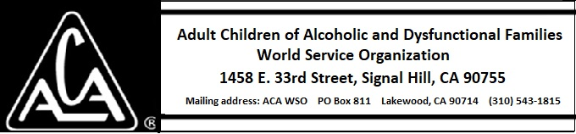

MONTHLY TELECONFERENCE AGENDA
April 14, 2018
2PM EST 712-432-0075 PIN: 427266#
Press *6 to mute or un-mute.

THIS IS A REGULARLY SCHEDULED MEETING WITH NOTICE GIVEN ON THE ACAWSO WEBSITE AND THE TRAVELER NEWSLETTER
Please notify the secretary with changes, additions, or motions for this meeting.

- Call to Order:

- Roll Call of Board Members:
Present:
Absent:

- Establish Quorum

- Minutes: Motion to approve the April 14, 2018 Teleconference Minutes (Marcia J.) Second:
Discussion:
Decision:

- Guest Introductions

- Tradition Five: Each group has but one primary purpose: to carry its message to the adult child who still suffers.
- Committee Reports: All reports can be found on the business website: http://acawso.org

  - Executive Committee—Majbrit M.
Nothing to report

  - Archive Committee—Marcia J.

  - Treasurer’s Report: David McB

Finance Committee: Pat H.

  - Literature Committee: Charlie H.

  - Members and Public Service Committee (MPS): Carole C.

  - European Committee: Majbrit M.

  - DCOC: Mary Jo L.

  - Audit Committee: Pat H.

  - Service Structure Committee: Marcia J

Website/Database Committee: Jim B.

  - ABC Committee: Jim R.

  - OPPM Committee: Mary Jo L

  - Nominating Committee: Greg R.

- New Business: General Commentary by Board Members on the 2018 ABC/AWC in Toronto

- 2018 ABC Motions and Status

  - We propose that WSO look into adding intergroup and meeting group web links into the WSO website directory listings on www.adultchildren.org.

  - We propose that the WSO utilize online conferencing and voting technologies to provide remote access to the Annual Business Conference, for those not chairing in the WSO. This is so that phone and cyber meeting groups, geographically distant members, those with limited time availability or childcare obligations, or other restrictions, may attend as delegates or otherwise vote on matters of concern to ACA as a whole.

  - We propose that both the ABC and AWC be held in Sweden next year if the Swedish agree to the extra work of the AWC.

- Guest Comments:

- Motion to close the meeting:
Second:
Decision:

Announcements: The next ACA WSO Board Teleconference is scheduled for June 12, 2018 at 2:00 p.m. Eastern time

