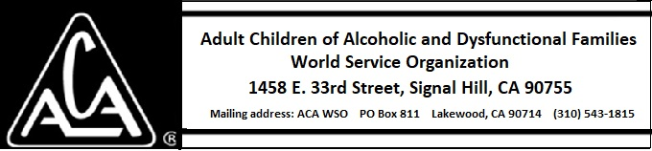

EXECUTIVE COMMITTEE ACTIVITY DURING MAY 2018

The Executive Committee approved of the following bids and purchases:

- A new timeclock for the Signal Hill office for $488 plus any applicable taxes from Amazon Prime.

Background: Signal Hill has an old timeclock that is no longer supported by the manufacturer and does not have the functionality WSO needs for remote access and download into the payroll system. The proposed model is the Icon Time Systems TP-BIO TotalPass Small Business Premium| Biometric Time Clock.

- A proposal from Assured Electrical Systems for relocation of lights for the Signal Hill warehouse for $825.

Background: The overhead fluorescent lighting in the warehouse interferes with putting pallets on the top shelves of the pallet racks. Two bids were solicited from licensed electricians to reconfigure the lights and the DCOC recommends the attached lower bid.

