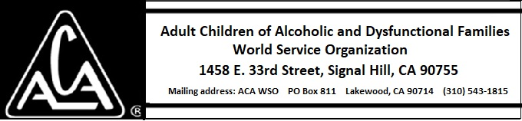

ARCHIVE COMMITTEE ACTIVITY DURING JUNE 2018

The committee currently has a board liaison, Marcia J. There is no chairperson as of this date. Marcia J. found information and a fall workshop from the Archive Committee for AA. This may be the next step we take. At some point in the future, the files will have to be examined on site.

