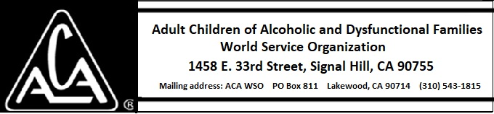

EXECUTIVE COMMITTEE ACTIVITY JUNE 9 THROUGH JULY 14 2018

The Executive Committee approved of the following purchase:

- A new desktop computer for the warehouse shipping work at Signal Hill for about $800.

Background: The existing unit has a Windows 7 operating system and is made by HP. Windows 7 is no longer supported with security patches by Microsoft and presents a liability to our network security.

