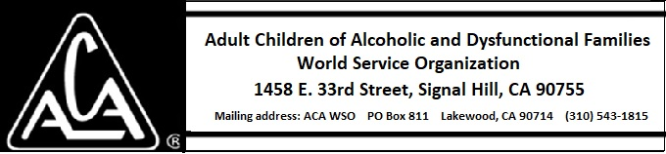

ARCHIVE COMMITTEE ACTIVITY THROUGH NOVEMBER 9, 2018

Mary Jo L, Marcia J, Sarah O. and Laura L met to discuss getting the Archive Committee restarted.
Laura L. is serving in an advisory capacity only. Marcia L. is the Board Liaison to the group.
ACAWSO Archives Vision Statement: The ACA Fellowship will have access to the history of the organization.
Archive Committee Mission Statement: The purpose of the Archive Committee is to gather, preserve and curate historical records, oral histories, and artifacts that document the history of ACA on the international, regional, intergroup and local levels and to make them available to the fellowship.

The term “archives” for the purpose of this committee means any records and artifacts of a historical nature dating from the creation and organization of the first groups of Adult Children of Alcoholics. This includes meeting minutes, recordings, artifacts, flyers, posters, local newsletters, and lists of past officers and their terms of office.
So far, two oral histories have been done, calls have been made to various members of the fellowship seeking archival materials, scanning of materials already at the Signal Hill office, and seeking advice for the process from those who may have experience in other organizations.

Those meeting agreed the most pressing concern is gathering materials so as to avoid their possible destruction as original members of the fellowship age. There is money in the archive budget to purchase a cross-reference database to help locate these people. After purchase of this tool we will start looking for contact information, making calls, and making arrangements to gather the materials.

The committee would appreciate any contact information for members or former members of the fellowship who may have information.

