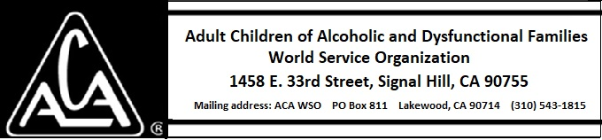

EXECUTIVE COMMITTEE ACTIVITY OCTOBER 12 THROUGH NOVEMBER 10, 2018

The Executive Committee voted to approve the following requests:

- 5,000 SC BRB for $10,043 10,000 hardcover BRB at a cost of $46,253 plus shipping from Bang Printing.

- 10,000 Yellow Workbooks $23,267 plus shipping from Bang Printing.

