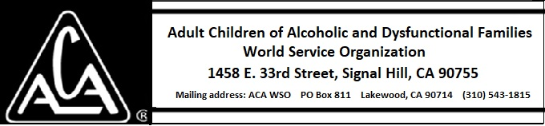

ARCHIVE COMMITTEE ACTIVITY THROUGH DECEMBER 4, 2018

A meeting of the committee was held in order to decide upon a budget for 2019. Our decisions were based on the means for gathering archival materials and oral history materials. Committee members will need some education as to proper curation methods as well.

