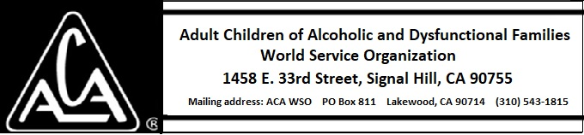

EXECUTIVE COMMITTEE ACTIVITY NOVEMBER 11 THROUGH DECEMBER 7, 2018

There is no report this month.

