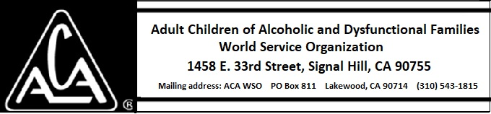

ARCHIVE COMMITTEE ACTIVITY THROUGH JANUARY 12, 2019

There is no report this month.

