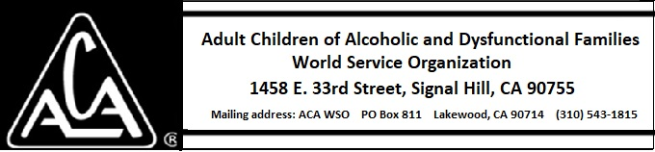

ARCHIVE COMMITTEE ACTIVITY THROUGH FEBRUARY 9, 2019

- Sarah O. reached out to an old-timer in the New York area and will be going to take an oral history soon.
- We have been contacted by someone who has quite a bit of records from the early days of ACoA.

