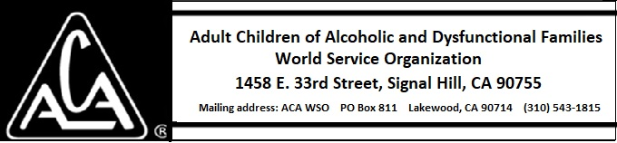

EXECUTIVE COMMITTEE ACTIVITY DECEMBER 8, 2018 THROUGH JANUARY 12, 2019

There is no report this month.

