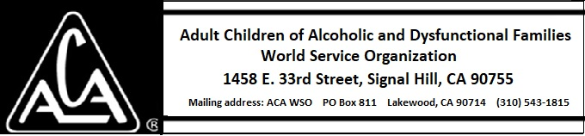

EXECUTIVE COMMITTEE ACTIVITY JANUARY 12 THROUGH FEBRUARY 8, 2019

The Executive Committee approved the following purchases:
- 5000 LLWB for approximately $16,000.00 plus shipping.
- 5000 hard cover meditation books for approximately $12,000.00 plus shipping costs.

