The Report for February, 2019
Submitted by Jim R., the ABC Committee Chair, March 9, 2019
HIGHLIGHTS FOR FEBRUARY:
- DELEGATE TRAINING – Delegate Training Page updated; creating a survey of Delegates.
- ABC PLANNING – Sent an example of the table and chair arrangement for the Conference room’ frequent calls with Fredrik; Parliamentarian challenges.
- DELEGATE BINDER – Call for Annual Committee Reports; offered suggestions for changes to the layout of Binder; framework of the document is in place. The content is arriving slowly. Two committees have been in correspondence; sent last year’s Binder, as a printing test.
- SWEDEN 2019 – Request from Nominating Committee for a ‘table’; sent photos of the printed programs of the 2017 and 2018 AWCs for guidance.
- FLORIDA 2020 – Host Committee in contact with Toronto Host Committee.
LOOKING AHEAD:
RECOMMENDATIONS: An umbrella ‘WSO Table’ be set up at the ABC/AWC, where attendees may ask questions and find information on a variety of subjects – committee work, WSO developments, outreach, volunteering opportunities.

DELEGATE TRAINING
The Delegate Training page, on the repository at acawso.org, is the primary site for all information pertaining to Conference delegates. The heading on this page offers links to, and description of, assorted documents – clear and helpful resources. acawso.org/category/delegate-training/.
Updates to the Delegate Training page are ongoing. Recent updates focused on Ballot submissions.
A survey for Delegates to take at the ABC is being fashioned. It will be in the Binder.
ABC PLANNING
The floor plan that was generated for the San Diego ABC was sent as an example of how the conference room in Malmö will be arranged. See below.

There are challenges with procuring a licensed Parliamentarian. We have strongly suggested to the Conference Chair, enlisting the support of a fellow ACA member with knowledge and experience of Robert’s Rules, to assist in the conference proceedings.

DELEGATE BINDER
The call has gone out to WSO committees for annual reports. In the past month we have received 1. It is attached below as a shining example.

Suggested improvements to the 2019 Binder have been offered to the Board. See below. Discussion of the material in the Board section has taken place. Without objection, the changes shall be implemented.

Last year’s Binder was sent to Sweden as a test to see how well the document would print. The reviews are in: “it turned out properly and looks adequate”. I will ask for pictures.

SWEDEN 2019 - The ABC/AWC
Weekly phone calls with Fredrik, Chair of the Host Committee, continue.
Registration numbers:
- 270 attendees for combined ABC/AWC
- 62 registered for the ABC (includes 17 associated with WSO)
- 15 remote voters (though likely it’s 10, as some of those listed are from Sweden)
- 30 “questionable” registrations – email address/group affiliations, etc., but no ABC/AWC, hotel or meals are indicated in the registration. This is being investigated.

The Swedish committee tasked with designing and printing the paper programs for the AWC were sent photos of all the pages of the programs from the 2017 and 2018 AWC’s. This was to offer examples from which they could work. It was recommended that the WSO websites and links be included in the program – such as adultchildren.org and Comline and Traveler information.

The Nominating Committee requested a table where they could provide information for ABC/AWC attendees. This request has grown into the suggestion that the WSO Board consider establishing and manning a table where all committees can offer information and answer questions. This has been done in the past to varying degrees.

FLORIDA 2020
The Florida Host Committee is in correspondence with the 2018 Host Co-chair. They have been offered a lot of information on the structuring of specialized committees, the tasks to be handled, goals, timelines, and the analytics from 2018. Having this mentorship is a huge help.
LOOKING AHEAD
March is largely about gathering committee reports and compiling the Delegate Binder. Additionally, a lot of the details about the events in Sweden are double checked. Preparations are made for the Delegate Training Teleconference calls.

For comments and questions, please write to Jim R., at abc@adultchildren.org.

Attachments

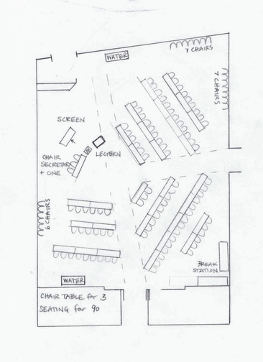
The Seating Plan from San Diego, 2017

This seating plan was offered as a suggestion for the seating arrangement for the conference in Sweden.

This type of semi-circular plan has been very successful in recent ABCs. This places the Chair, a possible Parliamentarian and whomever may be presenting, at the center of the proceedings. This arrangement also places the Board within the body of the worldwide delegation.

Images of the actual conference space are included below. The intension is to use half of the room, with a partition allowing for the setup of subsequent activities in the adjoining space. If the numbers for the ABC warrant more space the partition will not be used.

A picture of the dining facility is included.
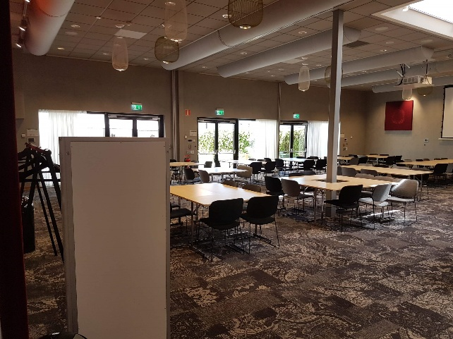
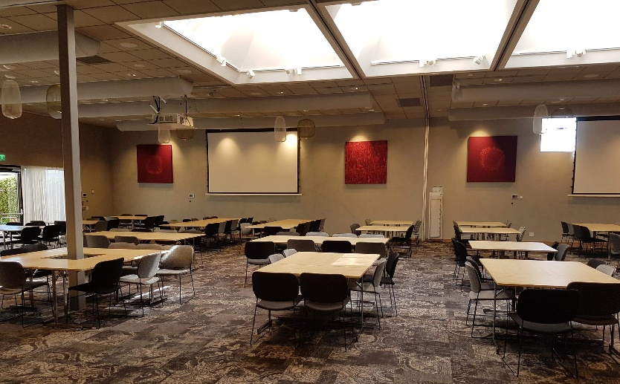
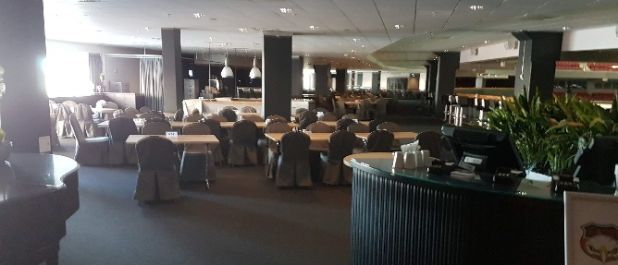

The Delegate Training Subcommittee Report
Chair: Erin D Vice Chair: Open Committee Members: Laura L. Mary Jo L. Jim R. Jody O. Chris W.
Meet on the fourth Wednesday of the month at 3 pm EST (Inception date 4/22/2017)

Purpose of Delegate Training Subcommittee (DTSC)
“to serve as a resource to help educate Delegates and Alternate Delegates of Groups and Intergroups to the Annual Business Conference by providing information on what is read prior to attending the conference, as well as helping Delegates be more informed in aiding their members/groups practice the Traditions, Concepts and holding group consciences.”

During 2018 the Subcommittee provided the following:
- Provided two segments at the ABC.
  - Day 1, Thursday, focused on General Procedures, Terminology, The Traditions and Concepts, The Delegates Role in the Conference: Accepting Reports, Ratifying the Board.
  - Day 2, Friday, Voting Procedures, Robert’s Rules of Order and introduced a Role Play on making a motion, voting, minority opinion etc..
- Two teleconference trainings were given in April. There were 28 attendees in all.
- Updated Welcome at A Glance letter to Delegates.
- Created a Frequently Asked Questions (FAQ) page.
- Created Before, During & After. This page aids Delegates on what to expect and when, so they may be prepared throughout the year.
SHINING
EXAMPLE

- Sent out a document by Mail Chimp to all registered meetings and Intergroups informing them of Ballot Proposals and the Delegate Role.

Currently underway:
- We are developing a training scheduled for the 2019 AWC on the use of Traditions in business meetings. This training will focus on educating Delegates and members alike on how to run effective business meetings by using Robert’s Rules of Order, the use of the minority opinion, and other strategies commonly employed in 12 Step fellowships. We will take note of how our Laundry List triggers cause us to react and how we can move past them in the moment, to instead be guided by spiritual principles of our Traditions. The premise of the workshop is that by providing education on these practices and procedures our members will be better equipped, confident and possibly motivated for service at all levels.
- Developing a committee timeline for future chairpersons to reference.
- Set weekly Teleconference training dates for April.
- Update Delegate survey for 2019 ABC.
- Working with Website and Data Committee to direct Delegates on remote voting.
- Access to registering Delegates from the host website.

Goals for the upcoming year:
Consider restructuring the Teleconferences and morning trainings to allow more time at the ABC for business. Options to be discussed are Welcome Meeting/Meet and Greet the night prior to start of the ABC and extending Teleconference Trainings prior to the ABC.

Repository of reports and instructional documents: https://acawso.org/category/delegate-training/
Contact: dtsc@adultchildren.org

NOTE: THESE PAGES HIGHLIGHT THE PROPOSED CHANGES TO THE DELEGATE BINDER.

The Delegate Binder

Of the 32nd Annual Business Conference

ADULT CHILDREN OF ALCOHOLICS ® / DYSFUNCTIONAL FAMILIES
WORLD SERVICE ORGANIZATION, INC.

Malmö, Sweden
April 25th and 26th, 2019

Welcome to the Delegates…
In English

In Swedish

Fredrik
Host Committee Chair of the 2019 ABC and AWC

Acknowledgements and Volunteer Appreciation…
English

Swedish

Table of Contents

Delegate Information Error! Bookmark not defined.
The Board of Trustees 9
Annual Reports 11
Ballot Proposals 13
New Literature and 15
Special Presentations 15
Foundational Documents Error! Bookmark not defined.

The Board of Trustees

The Delegate Binder
ACA World Service Organization, Inc.
2018 Annual Business Conference

SUGGESTED ADDITION TO THE SECTION
The 2019 Board of Trustees
And their Statements of Purpose

Charlie H.
Board Chair, Literature Committee Chair
Thank you to everyone. I came to ACA in 1985 after reading “It Will Never Happen to Me.” I was completely shut down, full of shame, and caught up in my own alcoholism. The program gave me my Higher Power and my feelings. It gave me a joyful healthy relationship with my wife. It also gave me a view of how tragic life as an untreated ACA can be and how joyful life is in recovery. I have been actively working in service in the Washington Area for many years. I was totally honored when asked to be on the Board of Trustees. I believe in transparency, honesty, and the group conscience. I have been on the Service Structure Committee and have a lot of hope for our group going forward. As Literature Chair, I want to make this program available to all levels of recovery.

Bill D.
Treasurer, XXX Committee Chair
My life has changed since I found this fellowship. I didn’t know this existed for a long time; I thought that it had gone away. I was so happy to find it. I tried to find emotional sobriety in another program for almost thirty years, but here, you people have helped me find it. I am so glad to have put that bag of rocks down, and I want to help other people put their bags down. I just signed my commitment to service, and it is more important today than it was last year, because I know what the work means. I promise you that if I am ratified I will make sure those promises happen.
PROPOSED
LAYOUT
TO INCLUDE:
TITLE
COMMITTEE WORK
TERM OF SERVICE
Mary Jo L.
XXX Committee Chair
I came from a small town in Wisconsin. I tear up a bit because I never would have imagined what this program would have done for me. I went to a retreat with Claudia Black 32 years ago and it changed my life. I am so grateful that I kept coming back. Service has helped me to grow so much as I peeled away pieces of my onion. I have been on the board for four years, and have had a lot of experiences that I think will help us in the future, but I am not tied to the past. We need to change with the growth of the organization. I am absolutely embracing the change. I look forward to it, and every opportunity for growth.

Majbrit M.
XXX Committee Chair, XXX Committee Chair
I came into these rooms on Monday 8 years ago. I had lost my job, my business, and my family. If it hadn’t been for a friend in AA who told me there was a fellowship like this I don’t know what I would have done. He was a drug and alcohol counselor, and gave me a book about it in Swedish. I decided to translate that book. It was about alcoholism, dysfunctional families, and how the alcoholic tries to provide healthy environment for their kids. I called this guy up and told him I couldn’t keep translating it was tearing me up. He sent me to a meeting 50 miles away. What kept me going was the courage and the honesty. My mother was an alcoholic and I was always covering up for her, always secretive until I

Annual Reports

The Delegate Binder
ACA World Service Organization, Inc.
2019 Annual Business Conference

Table of Contents

Annual Reports 11
The Minutes of the 2017 ABC Error! Bookmark not defined.
The Treasurers Report / 2018 Budget Error! Bookmark not defined.
The Executive Committee Report Error! Bookmark not defined.
The Literature Committee Report Error! Bookmark not defined.
The Finance Committee Report Error! Bookmark not defined.
?
The Distribution Center Oversight Committee Report Error! Bookmark not defined.
The Annual Business Conference Committee Report Error! Bookmark not defined.
The Delegate Training Subcommittee Report 4
The Ballot Prep Committee Report Error! Bookmark not defined.
The European Committee Report Error! Bookmark not defined.
The Member and Public Service Committee Report Error! Bookmark not defined.
The Intergroup Subcommittee Report Error! Bookmark not defined.
The Website and Database Committee Report Error! Bookmark not defined.
The Service Structure Committee Report Error! Bookmark not defined.
The Operating Policy and Procedures Manual (OPPM) Subcommittee Report Error! Bookmark not defined.
The Nominating Committee Report Error! Bookmark not defined.
The Archive Committee Report Error! Bookmark not defined.
The Audit Committee Report Error! Bookmark not defined.

Ballot Proposals

The Delegate Binder
ACA World Service Organization, Inc.
2019 Annual Business Conference

122 | Yes | 89% | Proposal 2018 – 5
15 | No | 11%
6 | No Opinion |  | Submitted on September 27, 2017 by Greater Toronto Area, CN (IG558)

We propose that WSO look into adding intergroup and meeting group web links into the WSO website directory listings on www.adultchildren.org.
History/Reasoning: We would like to easily access other fellowships web links for additional information and resources. The current directory on www.adultchildren.org does not contain web links.
Argument in Favor: This increases our ability to collaborate and share resources and new ideas as a fellowship. This will increase our healing opportunities with efficiency worldwide. Its grass roots sharing. Web links will afford the different fellowship groups and abundance of opportunities.
WSO Analysis: WSO agrees it is a good idea to provide web links on the WSO website for intergroups and meetings to our members to help us find each other better on the web. We think this can be achieved while still following the ACA Traditions. We expect this to be part of a newly designed website and meeting list that our Website and Database Committee hopes to unveil during the first quarter of 2018.
PROPOSED
LAYOUT
Comments:
In order to bring more attention to this
In the history/reasoning part we would like it clarified that it is only our fellowship, (Not other fellowships.)
Our interest is ensuring the committee report on efforts, plans and status of this initiative.
taken care of
We believe that increased web presence of individual ACA groups embarks on a slippery slope leading to “promotion rather than attraction.”
We feel the WSO is pedaling as fast as they can.
Would like clarification if intention is to have intergroup and meeting group links limited to ACA, or is it to include other fellowships?
WSO does not have world enough and time to investigate each and every site put up by each and every group that claims to be an ACA group to ensure compliance with our Traditions; ergo, while adding the URLs and e-mail addresses that can be copied and pasted, we don't think there should be any actual links.
Yes, Please o the above
NOTES:

New Literature and

Special Presentations

The Delegate Binder
ACA World Service Organization, Inc.
2018 Annual Business Conference

Introduction

Table of Contents if needed

New Literature

Special Presentations

