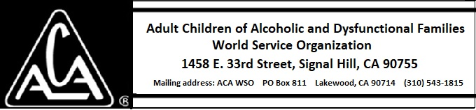

ARCHIVE COMMITTEE ACTIVITY THROUGH MARCH 9, 2019

Nothing to report.

