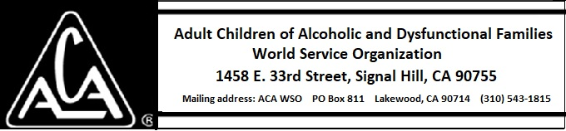

EXECUTIVE COMMITTEE ACTIVITY FEBRUARY 9 THROUGH MARCH 8, 2019

The Executive Committee approved the following purchases:
- 10,000 Newcomer Booklets from ABC Press for approximately $3,491.00.
- 5000 Finding Emotional Sobriety Trifolds from ABC Press for approximately $324.00.

The Executive Committee approved payment of $380.00 to Jim Mueller for administering the Hartman Value Profile to two new trustees and for short consultations about the results with both the trustees and the board.

