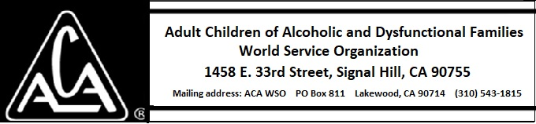

EXECUTIVE COMMITTEE ACTIVITY MARCH 8 THROUGH APRIL 9, 2019

The Executive Committee approved the following purchases:
- Purchase of a gift not to exceed $60.00
- Finding Emotional Sobriety Trifolds from ABC Press for approximately $324.00.

