March 2019 Activities of the Service Structure Committee

The Service Structure Committee met three times in March.

- The requirements for Regions to send a representative to the Board of Trustees was finalized.

- The Board agreed that the name of this Committee would change from “Service Structure” to “Service Network” to better describe the committee’s function.

- Our recommended

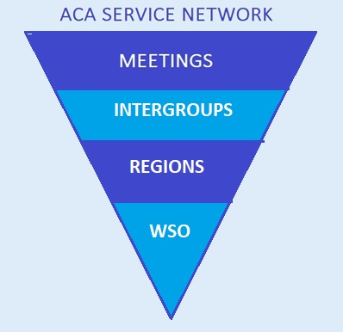

- The ABC presentation was mapped out.

- Our 2019 Report to the ABC with goals for the coming year was finished and sent to Jim R. for inclusion in the Binder.

Committee members: Marcia J and Charlie H. are leaving the committee after the ABC. Jim B. has been appointed by the Board of Trustees as Chair of the Committee. There has been no decision about the naming of a Vice-Chair.

Jim B. FL  Carole C. CA  Sarah O. NJ | Matt K. WI  - Miles C. ONT  - Bonnie K-M TX

If you would like to participate in this important work for the future of ACA WSO please feel free to contact Marcia J. at secretary@adultchildren.org On behalf of the committee, we are grateful to be of service to the fellowship that has given so much to us and many others.

I feel very good about the accomplishments of this committee since it was established in 2016 as an Ad Hoc Committee of the Board with Bill D. as the Chair. We have studied the current situation of the fellowship and made recommendations to the Board about areas of change, recommended the structure for the Nomination Committee, piloted the first ACA Town Hall, come up with a definition for the entities in the Service Network, and brought recommended criteria for Regions to be certified and qualified to put a Regional Trustee on the Board.
I thank those who have worked hard with me to achieve the above goals, and wish Jim B. and the committee much success in the future.

Marcia J.
Outgoing Service Structure Committee Chair

